2022 Campaign Toolkit
Our Promise: California State Employees Giving At Work
October 1 – December 31, 2022

Help spread the word to encourage fellow state workers to donate to their favorite nonprofit. Please use this toolkit as a starting point for messaging and personalize as you see fit.

Contents

Campaign Details 1
Sample Campaign Timeline 1
Nonprofit Outreach Program 2
Sample Email – Campaign Launch 2
Sample Email – Mid-Campaign Email 3
Sample Email – Final Call Email 4
Sample Email – Campaign Kickoff Event 5
Sample Departmental Newsletter 5
Sample Social Media Posts 6
Important Campaign Links 8

CAMPAIGN DETAILS
How long does the campaign last?
From October 1 – December 31, 2022, any California state employee can pledge or change their monthly payroll deduction, or make a one-time gift to help Care for California and support a nonprofit of their choice through Our Promise.
Which organizations are eligible for donations?
Through the Our Promise campaign, you can donate to any 501c3 nonprofit organization. You can search among our Certified Nonprofits or enter a tax-ID number.
How do I donate?
Visit Cal Employee Connect to donate online.

sample campaign timeline
Large departments should run a month-long campaign.
- 2 Months Before Launch
  - Campaign representatives are chosen

  - Leaders United executives reach out to campaign representative and set up introduction meeting.
  - Campaign representatives start campaign planning
  - Determine how leadership will be involved
  - Determine campaign timeline and dates
- 1 Month Before Launch
  - Review prior campaign history data
  - Work with executive team to determine departmental fundraising goals
  - Hold e-Pledge training
  - Plan a special event (utilize nonprofit outreach program)
  - Plan communications using this toolkit as a guide (e.g., email, newsletters, intranet, social media)
- It’s Campaign Time!
  - Kickoff Campaign
  - Push out communications
  - Leadership sends out department-wide memo
  - Host your event
  - Keep your communications coming!
  - Get campaign data from Leaders United executive to review campaign dollars and donors

Nonprofit outreach Program
Inspire state employees to give during the Our Promise Campaign by connecting them with the nonprofit agencies who benefit from their generous contributions. The Nonprofit Outreach Program offers two services; choose the one that works best for your department.
- Speaking Engagements: Trained nonprofit speakers can join a meeting in person, virtually or provide a previously recorded video to share their nonprofit’s mission, programs and impact directly with employees.
- Nonprofit Fairs: Multiple nonprofits can join an event in person, virtually or provide a previously recorded video so employees can learn about multiple nonprofits and programs at once.

Sample Email – Campaign Launch
Subject: Make a Promise to Care for California
Note: These are only sample emails; you aren’t required to use them. Please use as much or as little literature provided here.
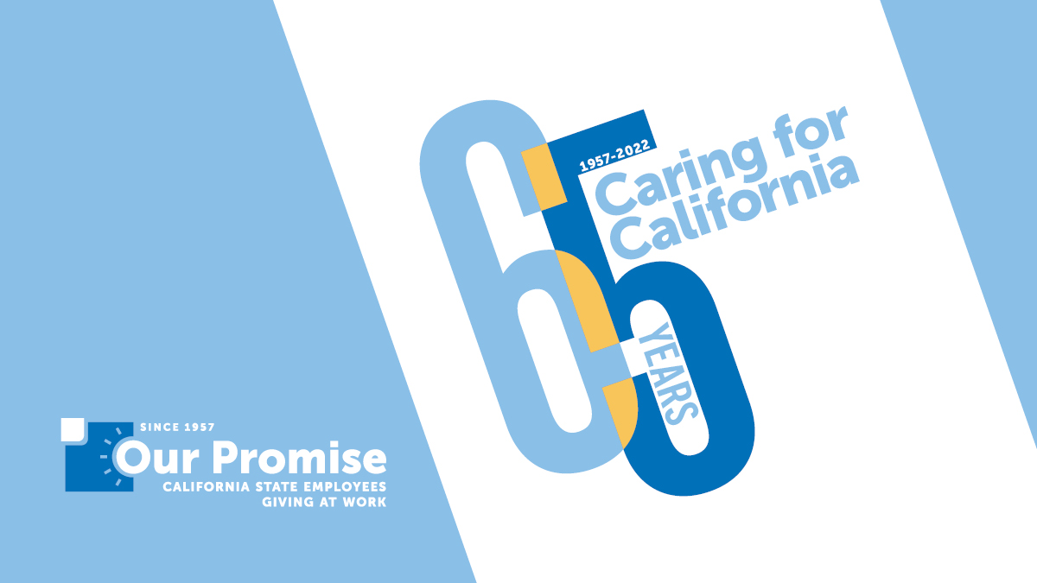
Join me and our fellow state employees in celebrating 65 Years of Caring for California! Together, we raise nearly $5 million for nonprofits every year during the Our Promise campaign. Show you Care for California by making a payroll deduction or increasing your donation during the Our Promise Campaign October 1 – December 31, 2022.
Nearly one in three California households lack the income to meet basic needs despite working full-time and nearly half of young children live in struggling households. Rising inflation rates, insufficient affordable housing and the threat of a recession are risking the livelihood and wellbeing of millions. Nonprofits throughout the state provide vital resources for people experiencing poverty, homelessness, food insecurity and more. And our neighbors need your support now more than ever.
You can Care for California with as little as $5 a month, the average cost of one latte. In solidarity with thousands of your colleagues, your gift will make a huge impact on the state and the lives of those relying on the services nonprofits provide.
Will you join me today and Care for California? Visit Cal Employee Connect to make your gift.
Thank you,
[Name]

Sample Email – Mid-campaign email
Subject: Now is the Time to Care for California
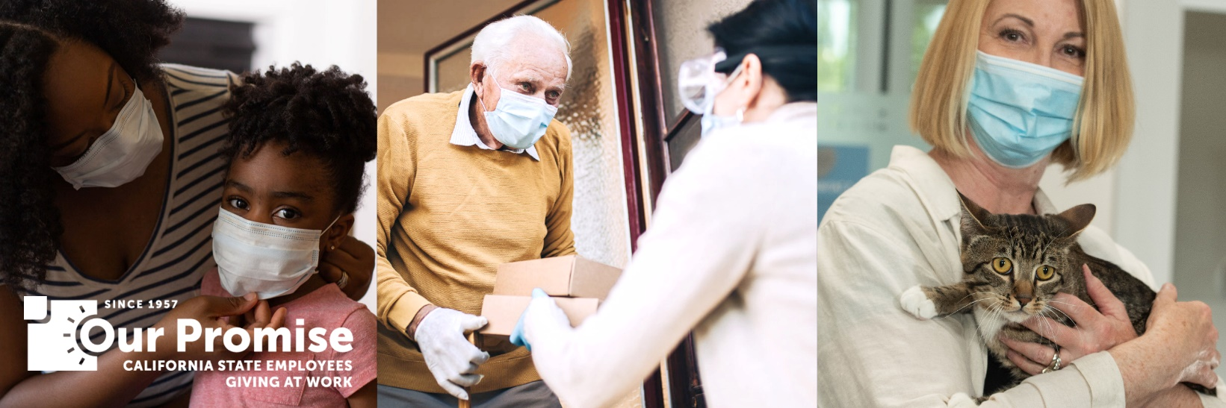
Now is the time to Care for California! Show you care about your community by making a payroll deduction or increasing your donation to your favorite nonprofit during the Our Promise Campaign. Make your gift by December 31.
Giving back is as easy as 1-2-3:
- Visit Cal Employee Connect. (You may need to set up an Our Promise account if you didn’t already do so.)
- Select your favorite nonprofit(s). If they are not among our certified nonprofits, you can still donate to them through the 'Write In' section with a valid Tax ID.'
- Complete your payroll deduction. We accept any credit cards with a Visa, MasterCard, Amex or Discover logo.
When you have made your gift, encourage 3 fellow State workers to do the same!
Thank you,
[Name]

Sample Email – Final call email
Subject: How Will You Care for California?
I’m proud to serve California and that so many public servants are making donations to Care for California. During the Our Promise Campaign, you have until December 31 to make a monthly payroll deduction or increase your gift to any 501c3 nonprofit of your choice. Visit Cal Employee Connect to make your gift today and help your community thrive.
Show you Care for California by December 31.
Thank you,
[Name]

Sample Email – Campaign Kickoff event
Subject: You’re Invited to the Our Promise Kickoff
We’re celebrating 65 Years of Caring for California! After a two-year hiatus, we’re once again gathering at the Capitol to kick off the Our Promise California State Employees Giving at Work campaign. Join me on October 4, 2022, 11 a.m. – I p.m., on the West Steps (1315 10th St, Sacramento).
Get inspired to give by visiting more than 100 nonprofit booths at this FREE and fun event for state employees. Learn how nonprofits are Caring for California and how your dollars can make a huge impact for your favorite cause.
How will you choose to make a difference this year? Pre-register by September 30 to be entered to win a prize!
Thank you,
[Name]

SAMPLE DEPARTMENTAL NEWSLETTER

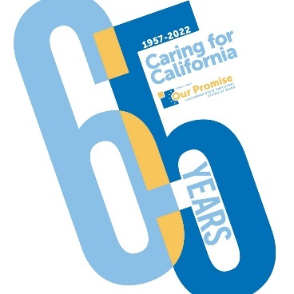
Show you Care for California by making a payroll deduction or increasing your donation during the Our Promise Campaign October 1 – December 31, 2022. Giving is easy! Simply register via Cal Employee Connect. Find a nonprofit cause that speaks to you and make your pledge. You can Care for California with as little as $5 a month, the average cost of one latte! In solidarity with thousands of your colleagues, your gift will make a huge impact on the state and the lives of those relying on the services nonprofits provide.

Sample Social Media Posts
Spread the word through your social media & be sure to tag us @OurPromiseCA!
Feel free to use the images in the OP Toolkit folder along with your messages.
SUBJECT | MESSAGE | PHOTO (Ctrl+Click to download)
OP Campaign Launch | It’s time for the Our Promise Campaign – join me and our fellow state workers in celebrate 65 Years of Caring for California!  Make a gift today to have a huge impact on the state and the lives of those relying on the services nonprofits provide.  www.ourpromiseca.org/2022-campaign
Mid-Campaign Reminder | Show you Care for California by making a payroll deduction or increasing your donation during the Our Promise Campaign October 1 – December 31, 2022.  With as little as $5 a month (the average cost of one latte) you can make a huge impact for your favorite cause.  www.ourpromiseca.org/2022-campaign | 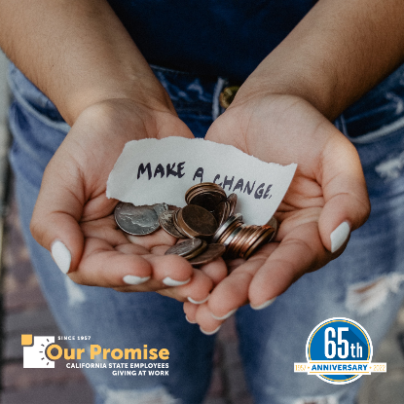
OP Kickoff Event | Join us on October 4, 2022, 11 a.m. – 1 p.m., on the West Steps (1315 10th St, Sacramento) to kick off Our Promise California State Employees Giving at Work campaign!  Get inspired to give by visiting more than 100 nonprofit booths at this FREE and fun event for state employees. Learn how nonprofits are Caring for California and how your dollars can make a huge impact for your favorite cause.  www.ourpromiseca.org/post/our-promise-kick-celebration | 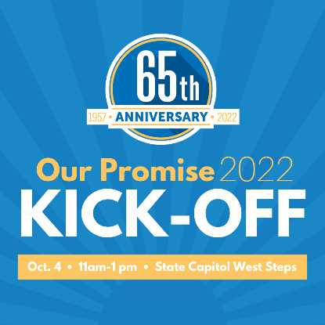
October Cause: Emotional Wellness Month | October is Emotional Wellness Month, and no one knows how important it is than the Our Promise CA nonprofit partner NAMI Sonoma County! Make a gift today to show your support (OP Code #1078948). | 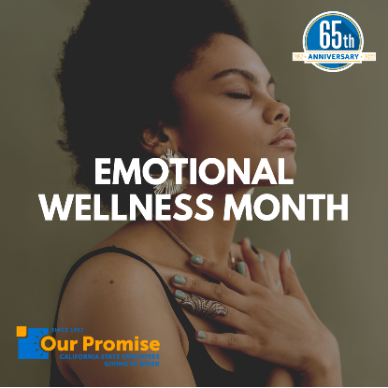
November Cause:  Native American Heritage Month | It’s Native American Heritage Month, and Our Promise CA is shining a spotlight on their nonprofit partner Sacramento Native American Health Center! Give now to support their amazing work (OP Code #2390268). | 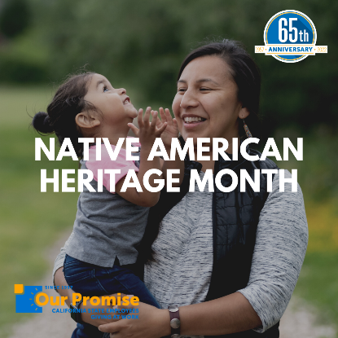
December Cause:  Universal Human Rights Month | Did you know December is Universal Human Rights Month? Our Promise CA wants to shine a spotlight on their nonprofit partner, Bay Area Legal Aid. Why not donate to their cause today to support human rights? (OP Code #765453)
Fun: October | It may be #SpookySeason, but the only thing we’re trying to be scared by is how scary-generous California state employees are! 👻  Get in on the action and make a gift to your favorite cause now. www.ourpromiseca.org/2022-campaign
Fun: November | Feeling extra thankful this time of year? 🍂  Why not pay it forward and donate to one of the many nonprofits Our Promise CA supports through their giving campaign? www.ourpromiseca.org/2022-campaign | 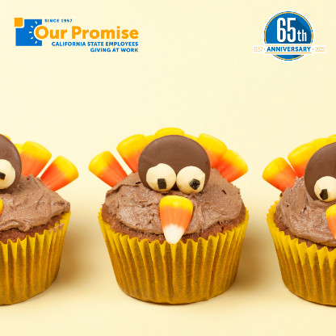
Fun: December | ‘Tis the season for giving! 🎁  Avoid a lump of coal by donating through Our Promise CA before it’s too late. www.ourpromiseca.org/2022-campaign

Important Campaign links
- Our Promise Website: www.ourpromiseca.org
- Our Promise Campaign Webpage: www.ourpromiseca.org/2022-campaign
- Cal Employee Connect: www.connect.sco.ca.gov
- Campaign Materials: www.ourpromiseca.org/campaign-materials
- Our Promise Kick Off Event Registration: www.ourpromiseca.org/post/our-promise-kick-celebration
- Nonprofit Outreach Program: www.ourpromiseca.org/nonprofit-outreach-program
- Videos to Share: www.youtube.com/channel/UCjHXsAmvCkwl0P3SMZmbd5A/videos

