CALIFORNIA STATE EMPLOYEES

GIVING PORTAL

HOW
TO

GUIDE

join Our Promise in three easy steps

This year, setting up your monthly charitable gift is as easy as 1-2-3 with the Our Promise Online Giving Portal.

To get started, be sure that you’ve signed up for an account with

Cal Employee Connect
first. Login between September 1 and October 31,
2020

to

find

the

“Click

to

Enroll”

button

on

your

User

Profile

page
.

Complete
the

registration

process

on

the

new

Our

Promise

Online

Giving

Portal
.

1
Register to access ePledge portal.

2
Then ask yourself, “What am I passionate about?” Find one of the many certified nonprofits listed in this Nonprofit Guide (NPG), or search online at OurPromiseCA.org/find-nonprofit. You may also give to ANY
 |  | nonprofit with a valid 501(c)(3).
 | 3 | After you’ve explored causes that you’re passionate about, decide how much you’d like to donate per monthly pay period. Login to your new
Our Promise Online Giving Portal account to complete your e-Pledge.
Here you can indicate which nonprofit(s) you wish to support and how much you wish to donate monthly or make a one-time gift. If you are an existing donor, you’ll be able to make changes, make a one-time gift, or cancel your payroll deductions.

YOU ARE NOW HELPING US
KEEP CALIFORNIA STRONG FOR ALL!

VISIT OurPromiseCA.org/2020-campaign FOR MORE
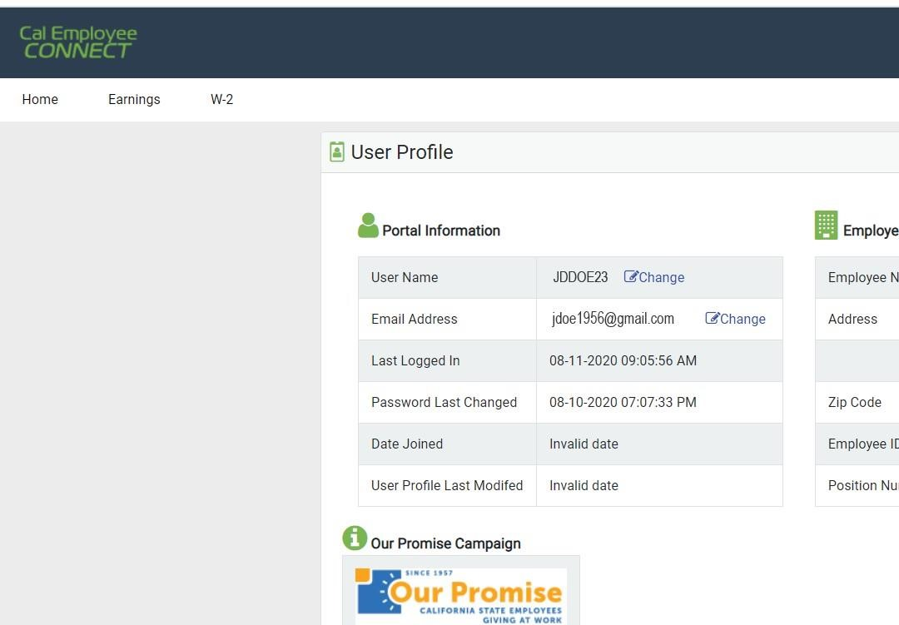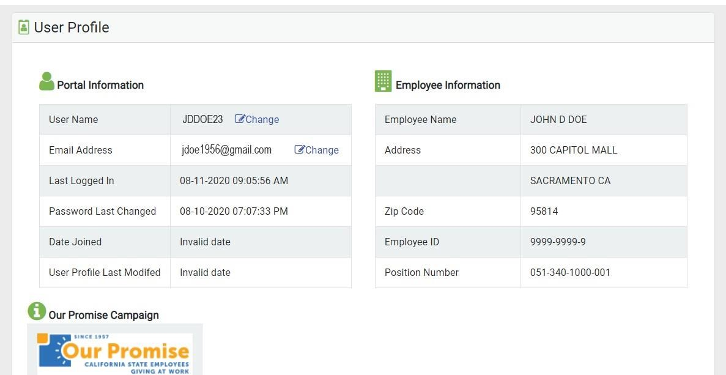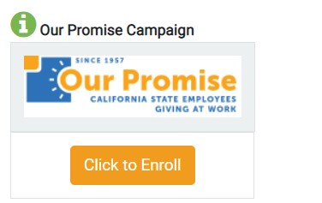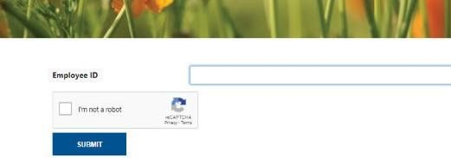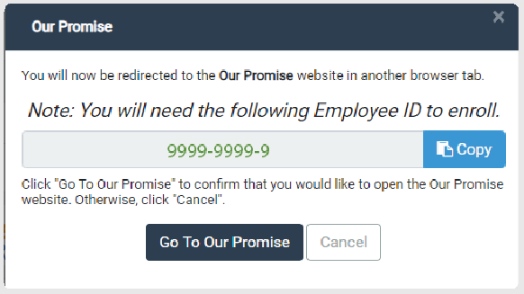
Copy

STEP
1

CREATE YOUR

OUR

PROMISE

ACCOUNT

CONNECT

From your Cal Employee Connect page, click

and then select the
Our Promise

Click to Enroll

button.

NOTE

If you haven’t
signed up yet for

you’ll need to
do that first.

A pop
-
up will appear, allowing you to copy your
Employee ID
number.

After you click the
button, select

Go
To
Our Promise

.

A new tab will open. Paste your Employee ID in the designated box.

USER PROFILE

REGISTER
Please enter your information to create your account. Steps will include:
- Creating a User ID and Password.
- Entering your home address, email, and phone (as your work info may change).

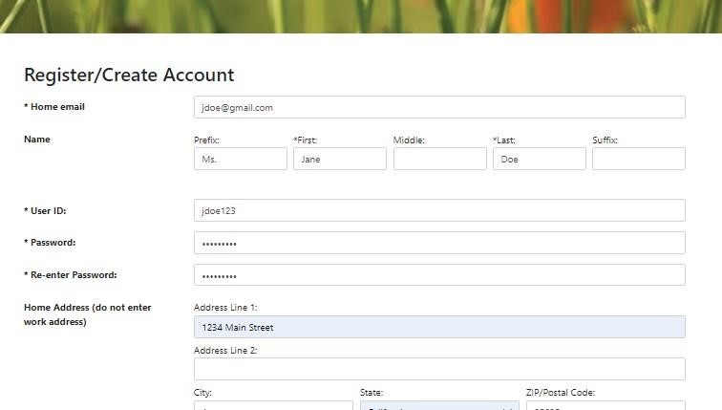
You will receive a verification code in the home email address you provided.

Use this code to enter into the popup box asking for your verification code on the CA State Employees Giving Portal.

Enter your new User ID and Password to log in.

You
can return to this portal any time
throughout

the

year

to

manage

your

donation!

DID
YOU

GIVE
LAST

YEAR?

YES

NO

If

you

did

NOT

give

last

campaign

year,
skip this page and proceed to STEP

3
.

STEP 2

EXISTING DONORS
If you have been contributing through Our Promise, THANK YOU!

Your account information will populate in the new online giving portal so you can REVIEW your existing donation and your designated nonprofits/amounts.
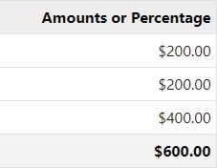
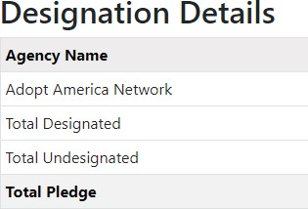
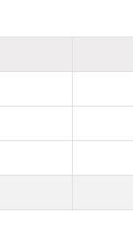
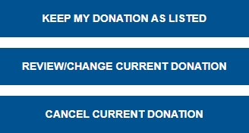
In this example, the employee donates $50/month for a yearly total of $600. They have designated $200 of the total to the nonprofit “Adopt America Network.” The remaining undesignated amount of $400 will automatically go to their local United Way.

CHOOSE YOUR ACTION

This selection
will take you
to STEP
3

KEEP MY DONATION AS LISTED
Just confirm on the next screen and you’re all done.
You have chosen to continue on as an Our Promise donor. Thank you for keeping California strong for all.
REVIEW/CHANGE CURRENT DONATION
- Increase/decrease your total donation,
- Add/remove nonprofit organizations, and/or
- Adjust the amount(s) designated. Payroll donation changes are effective with the first pay period in January 2021.

CANCEL CURRENT DONATION
Simply confirm on the next screen. Payroll donation cancellations will be effective after the last pay period in December 2020.
STEP 3

MAKE YOUR PLEDGE
OUR PROMISE

Through the CA State Employees Giving Portal, you can:
- Donate through a monthly payroll deduction minimum only $5/month per nonprofit;
- Make a one-time gift; or
- Decline to give at this time.

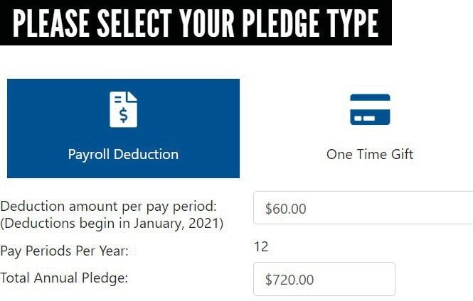
DETERMINE YOUR MONTHLY DEDUCTION
Decide how much you’d like to donate per pay period and enter it here.
Your Total Annual Pledge will be automatically calculated.

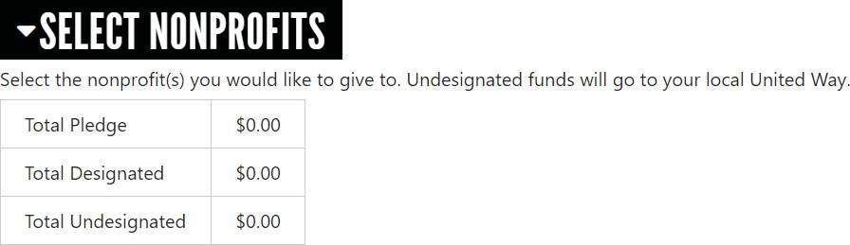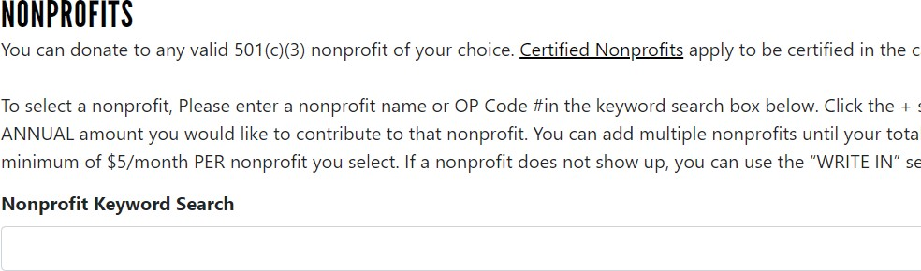
SELECT
YOUR
NONPROFIT(S)

optional

Your Total Pledge amount will reflect the

“Total Annual Pledge” amount from above.

As
you select your nonprofits and enter
your
TOTAL
ANNUAL pledge amount for
each

one,

the

amounts

will

automatically
accumulate

in

the

Total

Designated

box.

Any funds that remain
Undesignated

at

the

end

of

your

nonprofit

selection(s)
will

go

to

your

local

United

Way

office.

Use

the

Nonprofit

Keyword
Search
to find the nonprofit
you’d
like to

support.

Use the search bar to access our database of nearly 2,000 certified nonprofits across the state.
You can enter the nonprofit’s name, part of its name, or its OP CODE#.

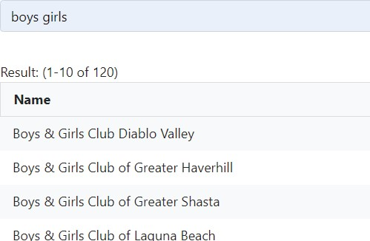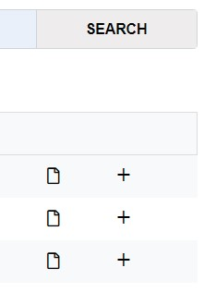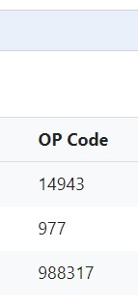ADD ANY WRITE-IN NONPROFIT(S) optional

When you find your
desired nonprofit, click
the

+
sign and enter the
total ANNUAL amount
you’d like to contribute
in the Designation
Amount field.

Click
+

to confirm
amount for that
nonprofit.

If your preferred nonprofit is not listed in our guide, and they have a current 501(c)(3) filing, 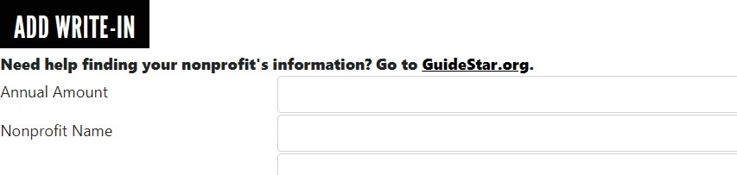visit Guidestar.org to find the tax ID/EIN to easily complete this section.

Once you’ve entered your nonprofit’s
information, click

ADD

to include it in
your Total Designated donations.

REVIEW

Check all of your selections and the annual Total Designated amount. If everything is correct, scroll down and click CONFIRM . You’ll see a final summary screen to print for your records and also receive confirmation at your home email address.

All designations will go into effect January 2021.
You can use your new CA State Employees Giving Portal account to log in to make changes at any time.

YOU

ARE

DONE!

Thank

you

for

Keeping

California

Strong

for

All.

